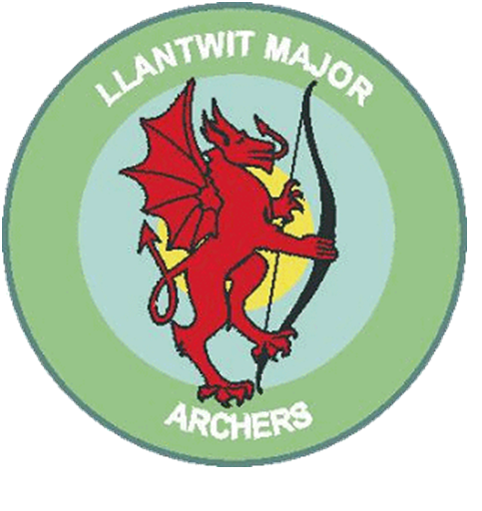
Llantwit Major Archery club

Adult Polo Shirt from £17.50 each
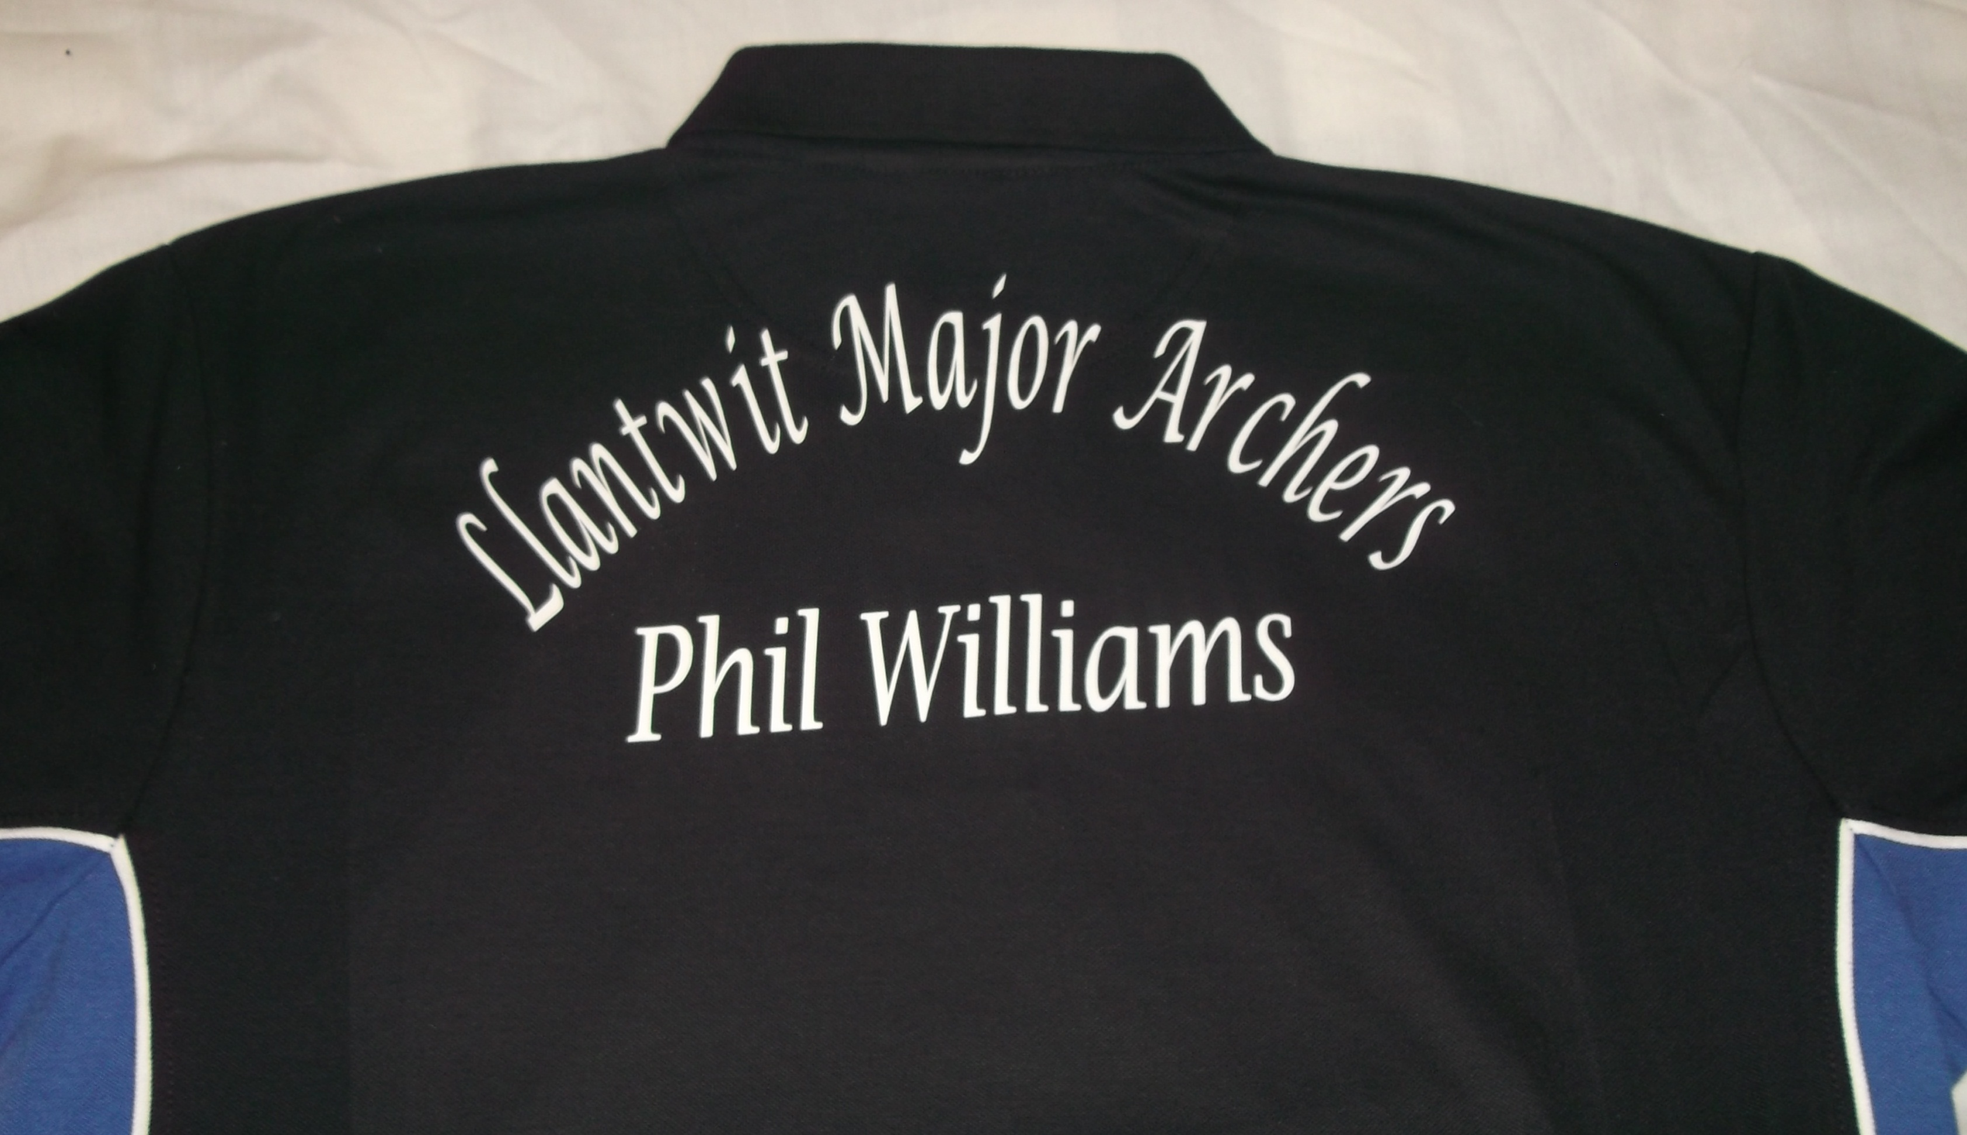
A quality Adult Polo Shirts with Llantwit Major Archers Logo on left chest panel, complete with Llantwit Major Archers vinyl printed on the reverse. Your name can be added on the back underneath the Llantwit Major Archers at NO EXTRA COST, this is optional.
If you require your name embroidered underneath the club badge on the front of the shirt this will cost an additional £1.50

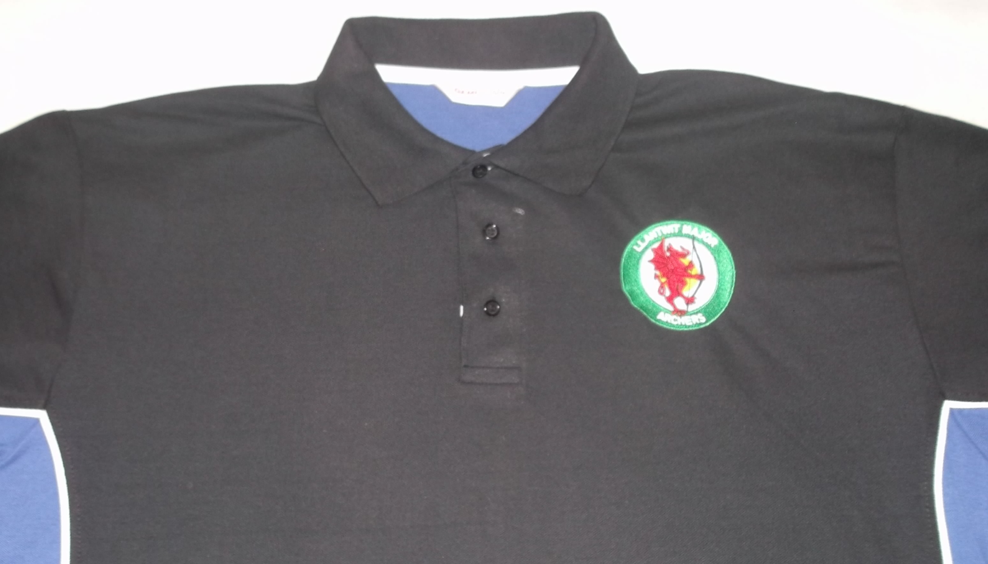

PLEASE ENSURE YOUR WRITING IS LEGIBLE!
ORDER NAME
Size | Qty | Name on Back FREE LEAVE BLANK IF NOT REQUIRED | Name of Front £1.50 PER SHIRT LEAVE BLANK IF NOT REQUIRED | Cost
XXS 28/30”
XS 32/34”
S 38/38”
M 40”
L 42”
XL 44”
2XL 46/48”
3XL 50/52”
 |  |  | Total

Please make cheques payable to Llantwit Major Archery Club
Return Forms to a Member of the Committee

